Advanced Programming ECE 241 Project 3 Aidan Chin

Part 2

1. Minimum value for price: 0.35311

Mean value for price: 1.8618897432762838

Maximum value for price: 7.55

Standard deviation for price: 0.8242982253562076

Number of houses: 817

1. 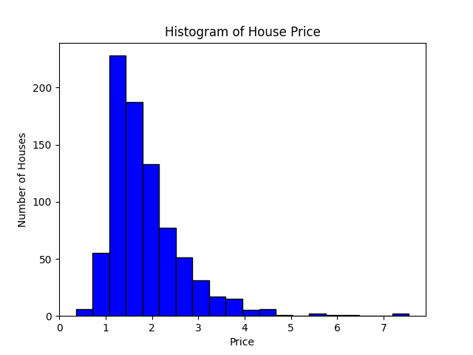
2. 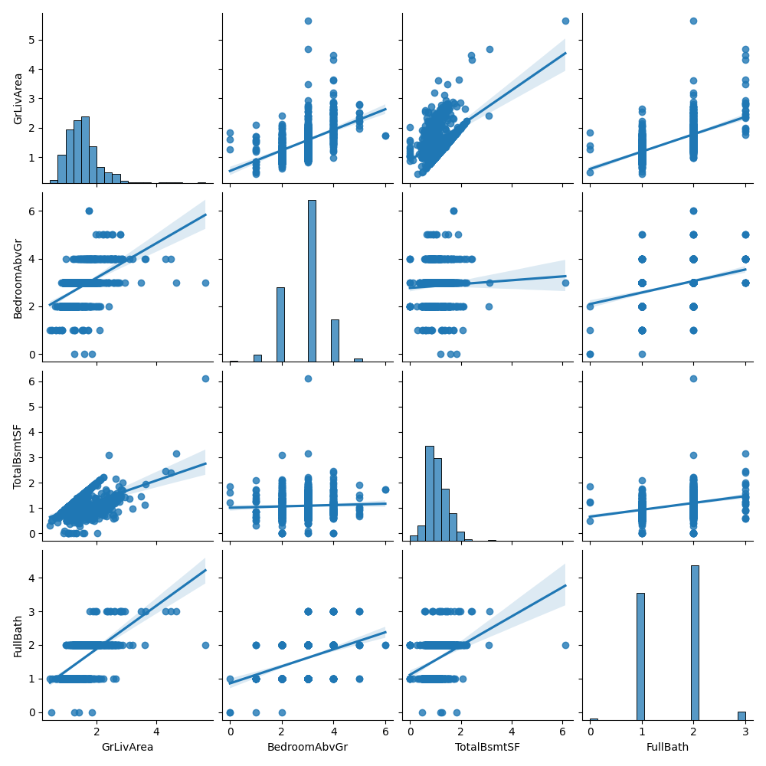

From the findings in this plot, the highest correlations are from bedroomabvgr for all across the board and fullbath all across the board. This suggests that there is redundant data. I would suggest removing these 2 from the dataset to improve learning time without compromising accuracy.

1. 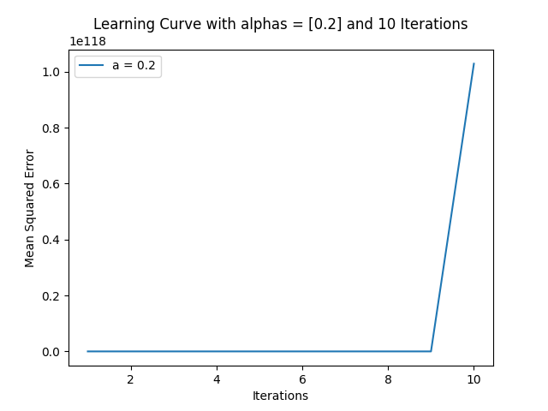

with the a value at .2, the MSE increases incredibly fast, it goes from 474105.3567108305 at 1 iteration 1.2664088209330762e+18 at just 2 and 2.60294485924787e+117 at 10. The reason this happens is because when the algorithm goes to correct the weights, the a value lets the weights change incredibly fast, not giving the algorithm a chance to converge on a solution, it overshoots too far every time it corrects itself.

1. 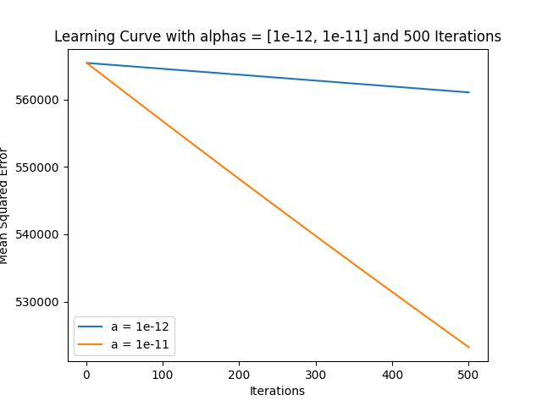
2. with the a value at 10\*\*-12 the learning rate is slower than 10\*\*-11 so 10\*\*-11 converges faster, using either of these values will not usually converge before the iteration limit is reached, I propose it would be better to use 10\*\*-9 or 10\*\*-10, thus I ran the algorithm with my values and got a nicer looking graph

1. The MSE using a = 10\*\*-11 during the training ended at 523232.01354840066 and the test MSE was 521826.97919621 and in the few times I tried it, the test MSE was consistently a little less than the training MSE but I predict that will not hold true in the future and it will average out to be about the same. This is because the training has not had time to overfit, and is still learning so the test and training set will have minimal difference in the eyes of the algorithm.